Act II:

Xamarin Forms with .Net Standard and Azure Client 4.x: A Real-World Quickstart

@DavidGerding, August 7, 2017

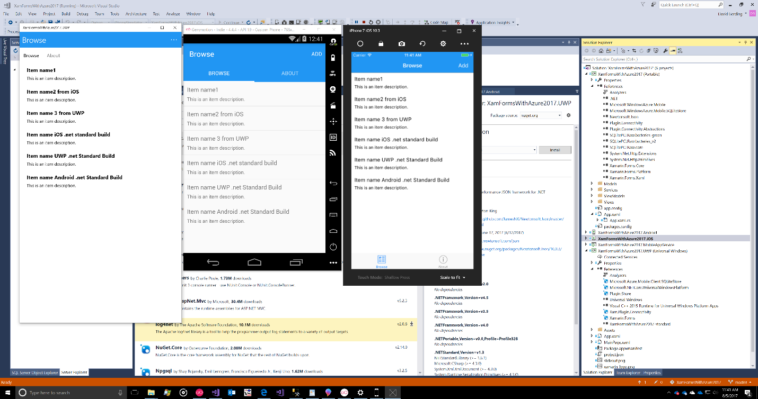

At the end of the “last act” we had gotten our walk-through to run on iOS, Android and UWP using the .net Standard project target for Xamarin forms and the Azure 4.0 mobile client build.

## Step 1 – Configure Your 3rd-Party Authentication

To use a third-party authenticator like Google, Facebook or a Microsoft account login you need to configure an app account with each of those services.

Here’s the information you’ll want to have handy and ready before you go to each of those services:

* a privacy policy HTML file and working URL to the same
* a terms of service HTML file and working URL to same
* an app icon file at 1024 by 1024

### Get Privacy Policy and Terms of Service Language

Privacy policy? Terms of service? Yep. These third parties are letting you authenticate using their platform and they need some basic measures of legitimacy and conformance to help their users know which app it is there signing into.

I think it makes sense to simply include a privacy policy.htm and a terms of service .htm file in your app service since in addition to being the backend of your mobile site it’s also, clearly, a web app that can serve webpages. :-)

You will find

* **PrivacyPolicy.html**
* **TermsOfService.html**

files in the root of the app service of this repo. There are a couple of links provided in each file to Google search results for policy generators you might try but I can’t vouch for them, use at your own risk, etc…

(For my own real app development, I like to use the privacy policy service [Iubenda](http://www.iubenda.com). It’s probably overkill but they have a lot of experience making sure that their language is congruent with the app store requirements for Apple and Android.)

### Your App Icon

I’ve also added a cheesy app icon in the root of the mobile app service. It’s a 1024 x 1024 png with transparency which is Facebook’s icon requirements for using their authentication. We’ll use Facebook as the example third-party authenticator since that’s the one the template defaults uses.

### Set Up a Facebook App Authentication Account

z

### Add the Facebook App Id, Secret and Callback Details in Azure

z